**Project Documentation**

**SHRI KRISHNASWAMY COLLEGE FOR WOMEN**

**DEPARTMENT OF COMPUTER SCIENCE WITH DATA SCIENCE**

**Project Title:**

**RhythmicTunes: Your Melodic Companion**

**(A Project Reported For Frontend Development)**

**Team ID :**

**Team Leader : Katherin.K (** [**katherinkatherin753@gmail.com**](mailto:katherinkatherin753@gmail.com) **)**

**Team member : Rithika.P (** [**rithikakr143@gmail.com**](mailto:rithikakr143@gmail.com) **)**

**Team member : Salma Begum.J (** [**shakila2810@gmail.com**](mailto:shakila2810@gmail.com) **)**

**Team member : HariHarani.S(**[**mahalakshmidurga10@gmail.com**](mailto:mahalakshmidurga10@gmail.com)**)**

**INTRODUCTION**

Rythmictunes is a personalized music experience designed to bring harmony into your daily life. Whether you're seeking relaxation, motivation, or creative inspiration, Rythmictunes curates melodies that resonate with your mood, preferences, and environment. Built with a passion for sound and a deep understanding of musical psychology, this project blends technology and artistry to deliver a seamless auditory journey. From ambient soundscapes to energizing beats, Rythmictunes adapts to your rhythm—making it more than just a playlist generator. It’s your melodic companion. Key Features: Mood-based music selection, Smart recommendations powered by user feedback, Minimalist, intuitive interface, Offline listening and custom playlists, Daily tune suggestions to match your vibeWhether you're a casual listener or a music enthusiast, Rythmictunes invites you to explore sound in a more meaningful way. Let your emotions guide the music—and let the music guide your day. In today’s fast‑paced world, music is more than a pastime—it’s a companion. *RhythmicTunes* aims to redefine how listeners discover, experience, and engage with music. Our vision is to build a streaming platform that responds to individual moods and moments; that intuitively adapts to a user’s context; one that serves not just songs, but curated experiences. We believe that every musical journey should feel personal, seamless, and inspiring. Whether someone is commuting, working, relaxing, or celebrating, *RhythmicTunes* should elevate those moments.*RhythmicTunes* is a React.js‑based music streaming application designed to address these gaps by offering:Personalised discovery: Intelligent algorithms that suggest tracks, playlists, and genres based on user preferences, listening history, and current context (e.g., mood, activity).Responsive UI/UX: Clean, smooth interface across devices—desktop, tablet, mobile—with attention to transitions, loading speed, and intuitive controls.Playlist creation & sharing: Simple tools for users to create their own playlists, share with friends, or get community suggestions.Rich audio experience: High‑quality streaming, easy navigation, search, recommendations, and perhaps integration of social or community features.TargetUsers **:** *Music Enthusiasts*: People who love exploring new music, genres, and sounds in their free time.*Casual Listeners*: Users who want a hassle‑free, mood‑matching soundtrack for their daily life—commute, workout, study, rest.*Curators & Creators*: Users who enjoy constructing playlists, discovering niche or emerging artists, and perhaps sharing musical tastes.Scope :This initial phase of *RhythmicTunes* will focus on:Building the core streaming engine: playback, search, basic recommendation system.Responsive front‑end with React.js: user registration, UI flows, playlist creation, browsing library.A set of curated content / genres, plus user personalization based on explicit preferences. Cross‑device compatibility (web,mobile‑friendly). Excluded (for initial version, may be future enhancements):Offline downloads (may come later).Fully refined context‑aware features (e.g. dynamically switching music based on sensor or time).Advanced social network integrations or deep community features. Success Criteria:To know that *RhythmicTunes* is succeeding, the following metrics (initially) will be important:User retention: % of users active week‑over‑week.Discovery engagement: How many users use the recommendation / “discover” features.Playlist creation & sharing: Number of playlists users create, time spent curating.Performance & usability: Fast load times, minimal buffering, intuitive UI flows.User satisfaction: Feedback, ratings, qualitative studies.

**SOURCE CODE**

// src/songs.js

export const songs = [

{

id: 1,

title: "Aurora",

artist: "Fog",

imageSrc: "https://images.unsplash.com/photo-1534790566855-4cb788d389ec?auto=format&fit=crop&w=800&q=60",

audioSrc: "https://www.soundhelix.com/examples/mp3/SoundHelix-Song-1.mp3",

},

{

id: 2,

title: "Voyage",

artist: "Tide",

imageSrc: "https://images.unsplash.com/photo-1473448912268-2022ce9509d8?auto=format&fit=crop&w=800&q=60",

audioSrc: "https://www.soundhelix.com/examples/mp3/SoundHelix-Song-2.mp3",

},

// ... include all other songs from your dataset

];

// src/SongCard.js

import React, { useRef, useState } from "react";

import "./App.css";

const SongCard = ({ song }) => {

const audioRef = useRef(null);

const [isPlaying, setIsPlaying] = useState(false);

const togglePlay = () => {

const audio = audioRef.current;

if (isPlaying) {

audio.pause();

} else {

audio.play();

}

setIsPlaying(!isPlaying);

};

return (

<div className="song-card">

<img src={song.imageSrc} alt={song.title} className="song-image" />

<h3>{song.title}</h3>

<p>{song.artist}</p>

<audio ref={audioRef} src={song.audioSrc}></audio>

<button onClick={togglePlay}>

{isPlaying ? "Pause" : "Play"}

</button>

</div>

);

};

export default SongCard;

// src/App.js

import React from "react";

import { songs } from "./songs";

import SongCard from "./SongCard";

import "./App.css";

function App() {

return (

<div className="app">

<h1>🎶 Rhythmic Tyunes</h1>

<h2>Your Melodic Companion</h2>

<div className="song-list">

{songs.map((song) => (

<SongCard key={song.id} song={song} />

))}

</div>

</div>

);

}

export default App;

/* src/App.css */

body {

font-family: 'Segoe UI', sans-serif;

background-color: #111;

color: #fff;

margin: 0;

padding: 0;

}

.app {

text-align: center;

padding: 2rem;

}

h1 {

color: #ff4081;

}

.song-list {

display: flex;

flex-wrap: wrap;

justify-content: center;

gap: 2rem;

margin-top: 2rem;

}

.song-card {

background-color: #222;

border-radius: 10px;

padding: 1rem;

width: 250px;

box-shadow: 0 0 10px #000;

transition: transform 0.2s;

}

.song-card:hover {

transform: scale(1.03);

}

.song-image {

width: 100%;

height: 200px;

object-fit: cover;

border-radius: 8px;

}

button {

margin-top: 1rem;

padding: 0.5rem 1rem;

background-color: #ff4081;

color: white;

border: none;

border-radius: 5px;

cursor: pointer;

}

button:hover {

background-color: #e73370;

}

<!-- public/index.html -->

<!DOCTYPE html>

<html lang="en">

<head>

<meta charset="UTF-8" />

<meta name="viewport" content="width=device-width, initial-scale=1.0" />

<title>Rhythmic Tyunes</title>

</head>

<body>

<div id="root"></div>

</body>

</html>

**OUTPUT SCREENSHOTS**

**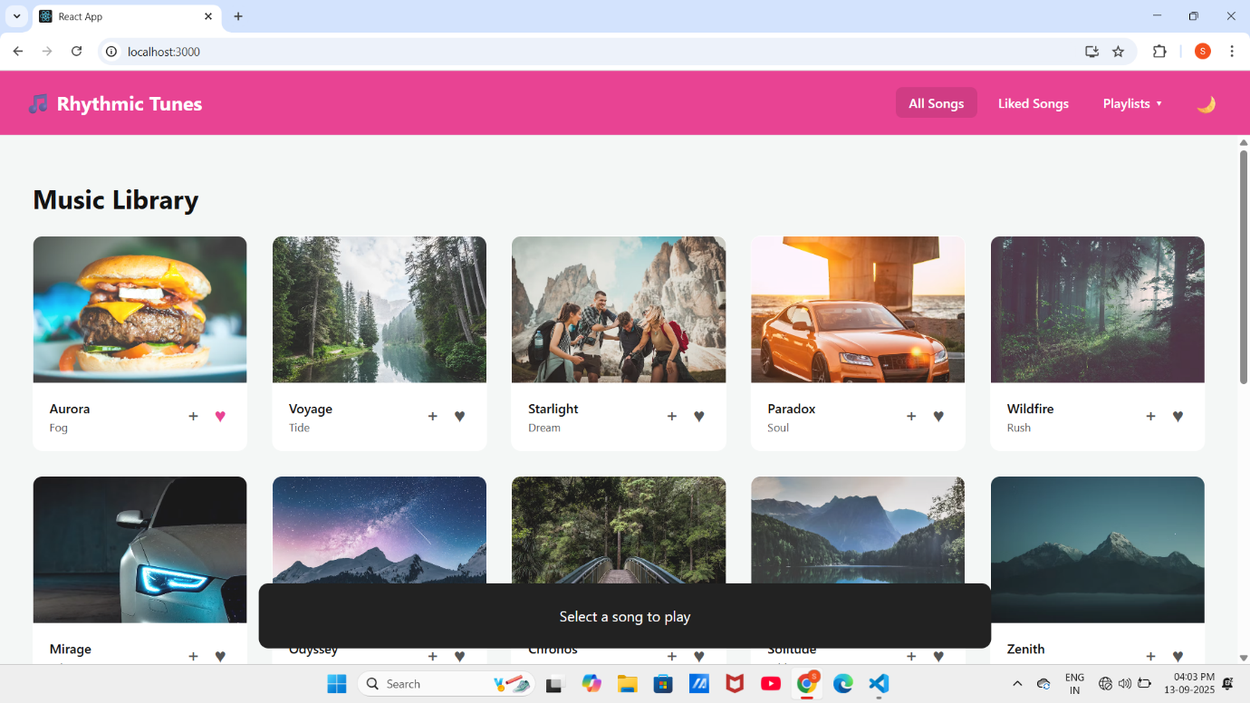  
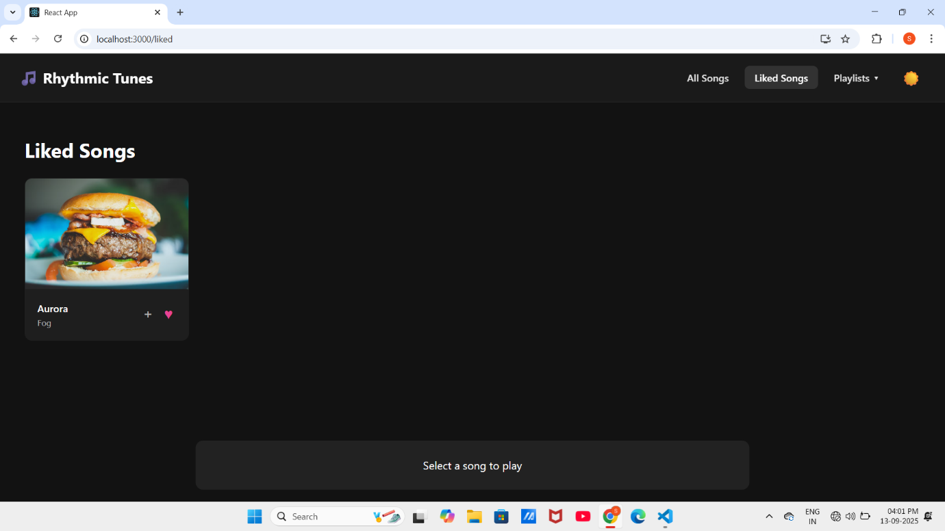**

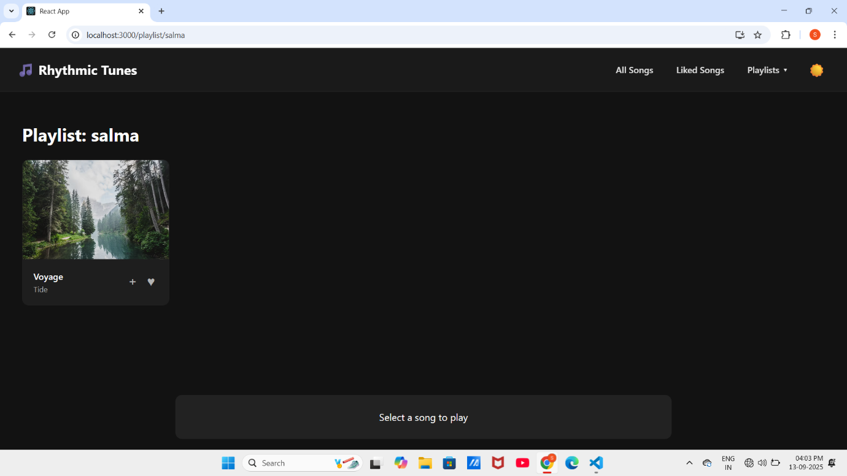

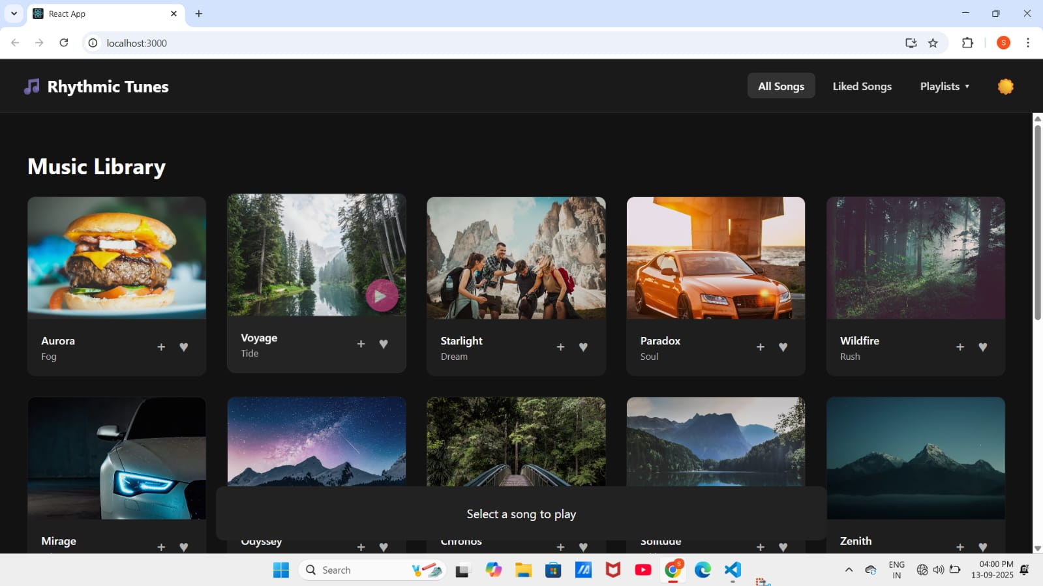

**DEMO VIDEO**

**Link:**

<https://drive.google.com/file/d/1URTzAPXp08MycWGm4QLGw_xExSixHnan/view?usp=drivesdk>